5.35: First, determine the acceleration from the freebody diagrams.

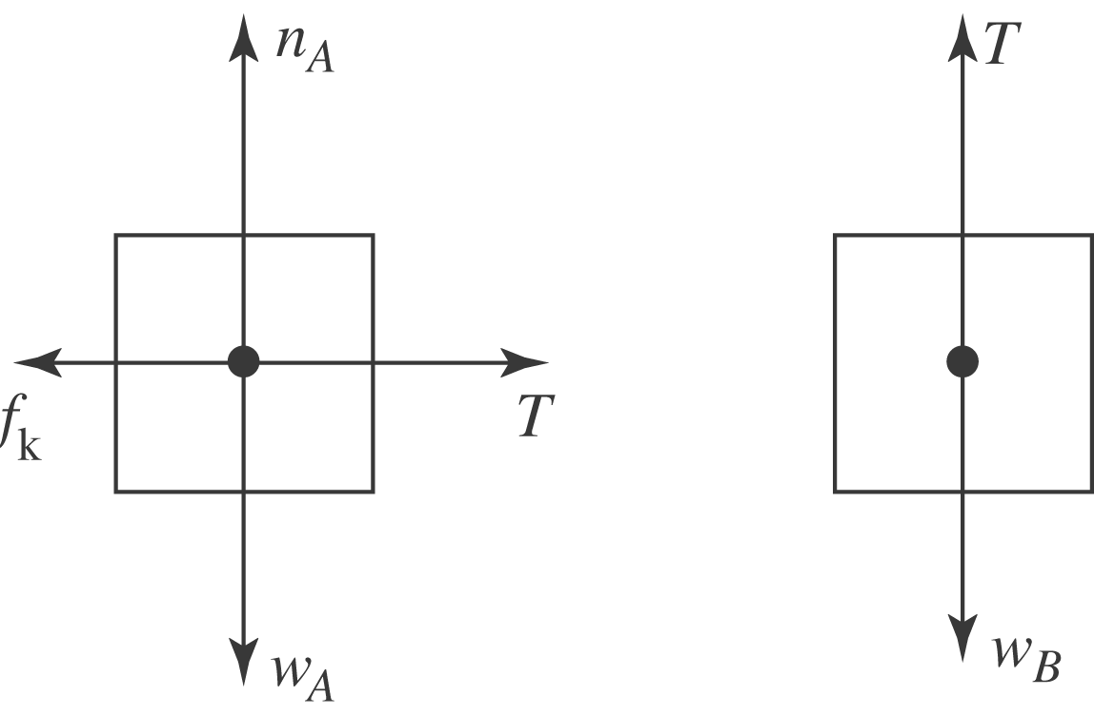

There are two equations and two unknowns, a and T:
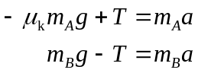
Add and solve for .
(a) 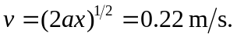
(b) Solving either equation for the tension gives 